|  |  |  |
| --- | --- | --- |
| **CS-1004 Programming Fundamentals** | **LAB - 05**  **Basic Decision Structure** | |
| **NATIONAL UNIVERSITY OF COMPUTER AND EMERGING SCIENCES**  **Fall 2021**  **NATIONAL UNIVERSITY OF COMPUTER AND EMERGING SCIENCES** | |  |

**Learning Objectives**

* Introduction to conditional statements
* If structure
* If –else structure
* If-else-if structure
* Switch statements

**Conditional Statements**

In C programming there are decision making statements, we need this kind of statements because while programming we often need to make a lot of decisions. Like shown below in the pictures.

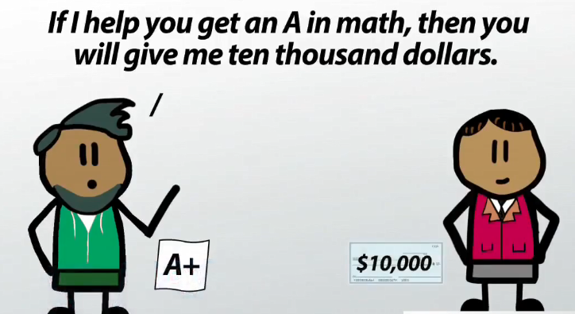

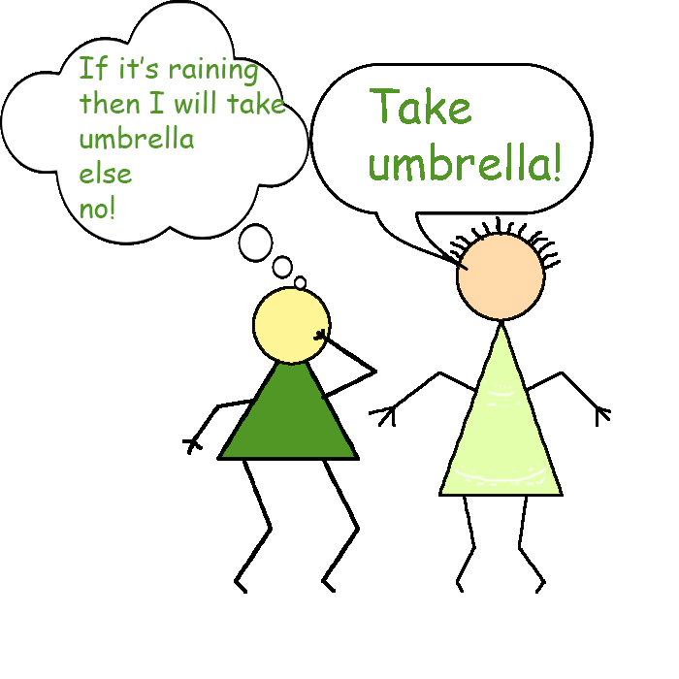

In some cases we need to execute this block of code

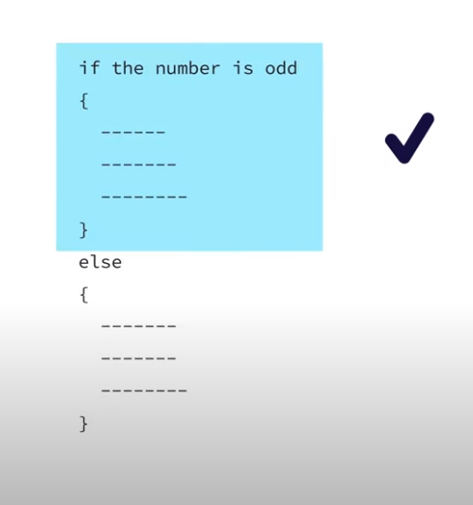

Otherwise we want to execute this block

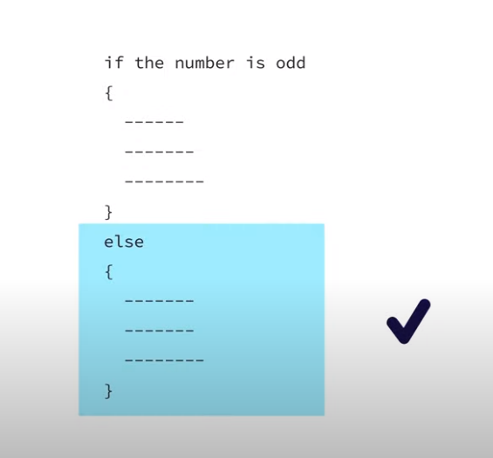

In C, an if/else statement specifies that one block of code should be executed if a condition is true, and another block should be executed if that condition is false.

To write meaningful if/else statements, it is important to know operators which allow us to compare two expressions and produce a Boolean outcome.

In C, however, there are no distinct values for true or false, instead, false is 0, and anything which is non-zero is true. We will refer to true and false because they make more sense conceptually; the distinction should not make a practical difference in most cases.

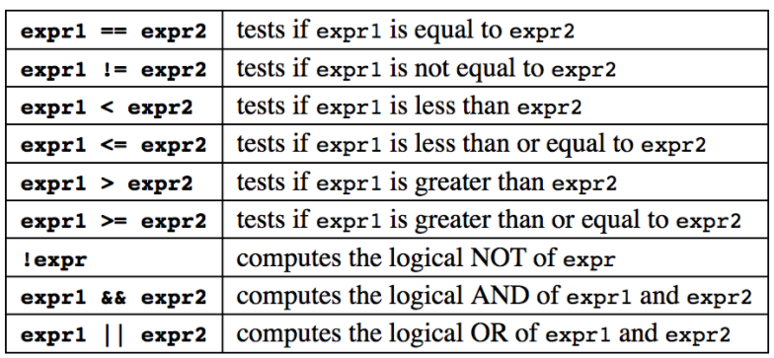

In 'C' programming conditional statements are possible with the help of the following two constructs:

1. If statement

2. If-else statement

It is also called as branching as a program decides which statement to execute based on the result of the evaluated condition.

**If statement**

An if statement consists of a conditional expression followed by one or more statements.

If the conditional expression evaluates to true, then the block of code inside the if statement will be executed. If conditional expression evaluates to false, then the first set of code after the end of the if statement (after the closing curly brace) will be executed.

**Syntax:** The syntax of an if statement in C programming language is:

**If (condition)**

**{**

**//statements;**

**}**

**Flowchart:**

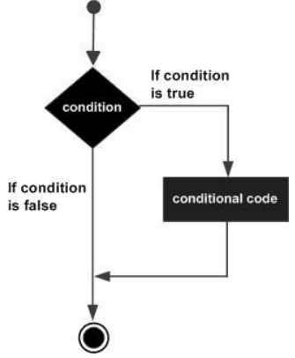

**Example: Checking if the number input by user is 0 or not. If its 0 then print Zero else print Non-zero**

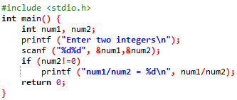

**If else statement**

An if statement can be followed by an optional else statement, which executes when the boolean expression is false.

**Syntax:** The syntax of an if...else statement in C programming language is:

**If (condition)**

**{**

**//statements;**

**}**

**else**

**{**

**//statements;**

**}**

**Flowchart:**

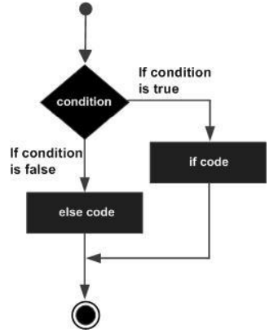

**Example:**

**Checking the value of variable a, if it contains 10 then print value of a is 10, if it contains 20 then print value of a is 20, if its 30 then print value of a is 20 otherwise print None of the value is matching**

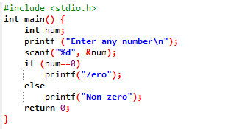

**If else if statement**

An **if** statement can be followed by an optional **else if...else** statement, which is very useful to test various conditions using single **if...else if** statement.

When using **if , else if , else** statements there are few points to keep in mind:

* An **if** can have zero or one else's and it must come after any **else if's**.
* An **if** can have zero to many **else if's** and they must come before the **else**.
* Once an **else if** succeeds, none of the remaining **else if's** or **else's** will be tested.

**Syntax:** The syntax of an if...else statement in C programming language is:

**If (condition)**

**{**

**//statements;**

**}**

**else if (condition)**

**{**

**//statements;**

**}**

**else if (condition)**

**{**

**//statements;**

**}**

**else**

**{**

**//statements;**

**}**

**Example:**

#include <stdio.h>

int main () {

int a = 100;

if( a == 10 ) {

printf("Value of a is 10\n" );

} else if( a == 20 ) {

printf("Value of a is 20\n" );

} else if( a == 30 ) {

printf("Value of a is 30\n" );

} else {

printf("None of the values is matching\n" );

}

printf("Exact value of a is: %d\n", a );

return 0;

}

**Problem**

**In FAST University 80% attendance is required for students to appear in the examination otherwise you won’t be able to sit in an exam.**

**Algorithm**

1. **Start**
2. **Input attendance of semester**
3. **IF attendance>=80**

**then**

**print “You are eligible for the Examination”**

**ELSE**

**print “Sorry you are not eligible for Exam”**

**END IF**

1. **END**

**Flowchart**

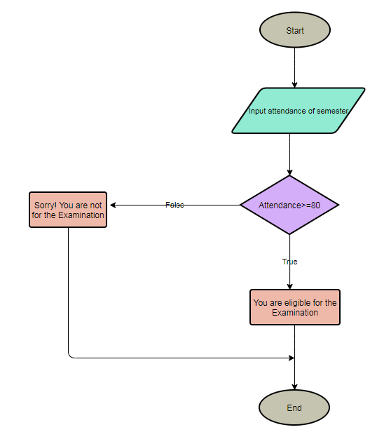

**C Code**

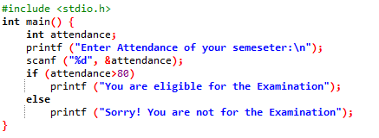

**Problem**

**FAST University wants to assign a grade to every PhD student according to the obtained marks. The grading criteria for the PhD students is given below.**

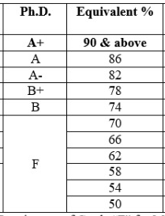

**Write a program to assign the grade to each student according to his marks.**

1. **Start**
2. **Input marks**
3. **IF marks>=90**

**then**

**print “You have got A+ grade”**

**ELSE**

**IF marks>=86**

**then**

**print “You have got A grade”**

**ELSE**

**IF marks>=82**

**then**

**print “You have got A- grade”**

**ELSE**

**IF marks>=78**

**then**

**print “You have got B+ grade”**

**ELSE**

**IF marks>=74**

**then**

**print “You have got B grade”**

**ELSE**

**print “You are fail”**

**END IF**

1. **END**

**Algorithm**

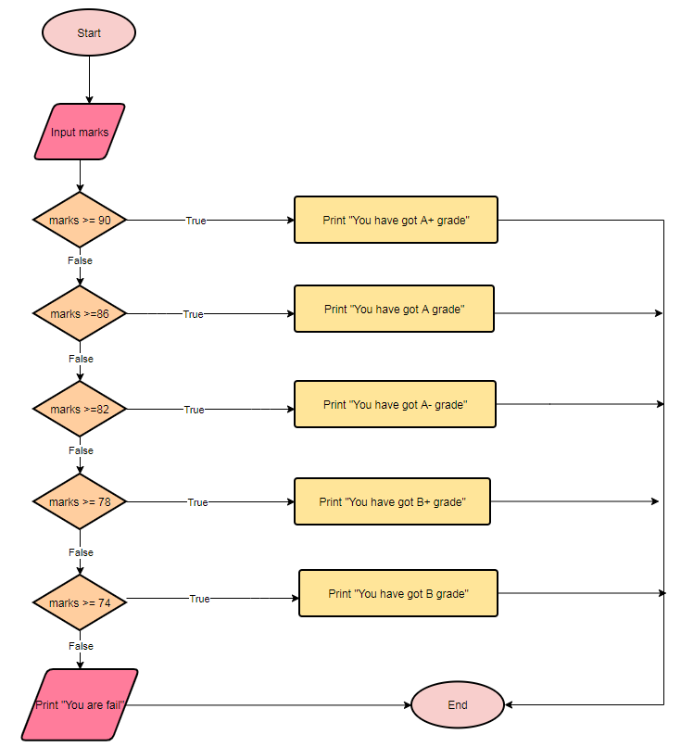

**C Code**

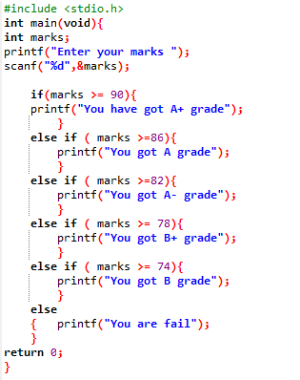

**Switch Statement**

Another way that programs can make decisions is to use switch/case. The syntax of switch/case is shown in the figure below.

**Syntax:**

**switch (selection expression) {**

**case 1:**

**//statement**

**break;**

**case 2:**

**//statement**

**break;**

**default:**

**//statement**

**}**

Here, when the execution arrow reaches the switch statement, the selection expression—in parenthesis after the keyword switch—is evaluated to a value.

This value is then used to determine which case to enter. The execution arrow then jumps to the corresponding case—the one whose label (the constant immediately after the keyword case) matches the selection expression’s value. If no label matches, then the execution arrow jumps to the default case if there is one, and to the closing curly brace of the switch if not.

✓

**switch (selection expression)**

**int / char**

**float / string**

The following rules apply to a **switch** statement:

* The **expression** used in a **switch** statement must have an integral or enumerated type, or be of a class type in which the class has a single conversion function to an integral or enumerated type.
* You can have any number of case statements within a switch. Each case is followed by the value to be compared to and a colon.

**Switch statement is better than if else statement**

A switch statement is **usually more efficient than a set of nested ifs**

Switch statement acts as a substitute for a long **if-**else-if ladder that is used to test a list of cases.

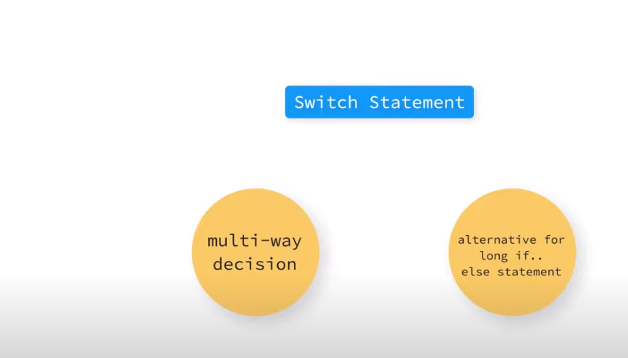

**Flowchart**

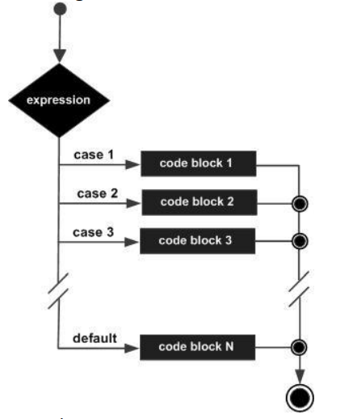

**Example: Calculator using numbers to choose operators, if 1 is pressed then addition is performed, if 2 is pressed then subtraction if 3 is pressed then multiplication, if 4 is pressed then division otherwise print invalid choice.**

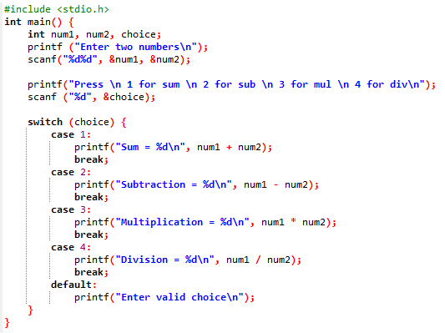

**Output:**

